Clemson University

Speeded Up Robust Features
Assignment 3, ECE 877
Ujwal C Naik
Assignment Number 3

Report for the 3rd assignment for Computer Vision – ECE 877.

Introduction:
SURF (Speeded Up Robust Features) is a feature-point detector that is scale and rotation invariant. SURF performs better than or equally well as SIFT in terms of repeatability, distinctness, and robustness and still is much faster than the SIFT algorithm. The speed achieved by SURF is by building on the strengths of current detectors and descriptors and simplifying these methods down to the required bare-minimum.
SURF uses the integral image which can be used to obtain the sum of values inside any rectangle in linear time. Using the integral image we can apply the approximation of 2nd order derivative filters and then obtain the features using non-maximal suppression over scale-space.

Method:
For the purpose of this assignment we have implemented U-SURF feature detector and hence we detect features over 4 scales in 1-single octave. Since we have implemented our algorithm over one octave only the detected features are not rotation invariant.
The method followed for implementation of U-SURF is as follows:
- Load the image: In this step we load the image and convert the image from colored to gray space.
- Calculation of the Integral Image: Using the gray-scaled input image we calculate the integral image which can be used to quickly calculate the sum of all the values inside a rectangle in linear time. The integral image is basically a running sum of values over the entire image. It is calculated using the following formula:
S(x,y) = I(x,y)- S(x-1,y-1) + S(x-1,y) + S(x,y-1).
- Applying 2nd derivative(approximate) filters to image: In this step we apply and compute the 2nd order derivative filters to the input image. The filter is applied to all the scales present in the octave we are considering and hence the second order derivative filter is applied using different scales. The scales increase by an order of 6 so as to preserve symmetry. The scales in the octave under consideration are 9x9, 15x15, 21x21 and 27x27.
- Non-maximal suppression and thresholding: Once the filters are applied we perform Non-maximal thresholding to obtain the feature points that are local maxima and capture and convey the most amount of information. This is done by scanning through the entire scale space to find the pixel that is locally maximum. Hence, for every pixel we search through the adjacent scale spaces eg. For the scale space 15x15 we search through the immediate neighbors and the pixels in the 9x9 and 21x21 for the local maximum. If the pixel is greater than all the 26 other pixels then it is chosen as a feature.
- Displaying the result: Once the feature is chosen it is displayed with a red circle if it is a bright area surrounded by dark pixels or using a blue color if it is a dark area surrounded by light pixels. The scale on which the detected feature exists decides the size of the radius of the circle being drawn.

Algorithm:
The algorithm for USURF is as follows:
- Load the image and convert to gray-scale.
- Calculate the integral image.
- Apply 2nd order derivative filters of scales 9x9, 15x15, 21x21, 27x27..
- Using non-maximal suppression and thresholding search through adjacent scale spaces to find local maxima. For each pixel we search the adjacent pixels in the scale space above and below the current scale space in addition to the current scale space.
- Display the result. The features that have bright areas surrounded by dark are marked with red circles and the areas that have dark areas surrounded by bright are marked with blue circles. The scale on which the feature is detected decides the radius of the circle.

RESULTS

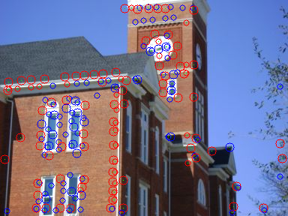

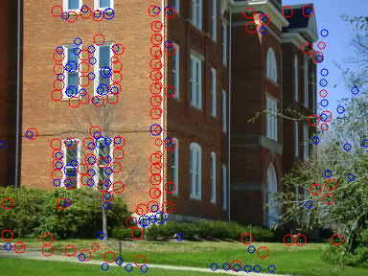

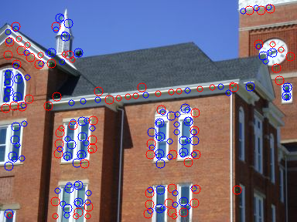

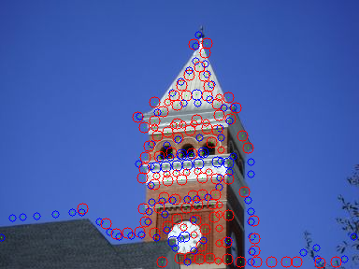

Conclusion
The SURF algorithm provides very robust features which are not only very distinct and usually convey significant amount of information but the results are also very repeatable.
The method described in the algorithm is faster than SIFT because SURF reduces the required number of calculations and simplifies the required calculations to the bare minimum.
Also, SURF is more robust than SIFT while handling blurring and rotations. Whereas, SIFT has the upper hand when it comes to handling viewpoint change and change in illumination.

